1)
Tell whether the histogram is uniform, symmetric, or skewed.
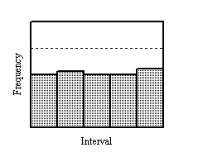
A.
uniform
B.
symmetric
C.
skewed

2)
Tell whether the histogram is uniform, symmetric, or skewed.
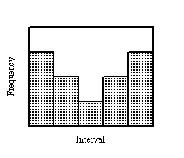
A.
uniform
B.
symmetric
C.
skewed

3)
The number of crows observed per day on a certain field over a two-week period is listed below. What is a frequency table and histogram that represents the data?
1, 3, 2, 5, 10, 8, 9, 15, 0, 7, 12, 13, 6, 18
A.
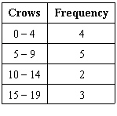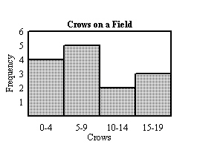
B.
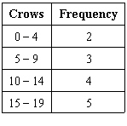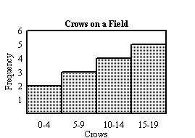
C.
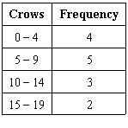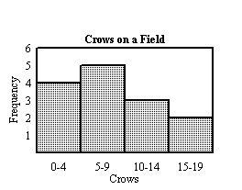

4)
What are the mean, median, mode and range of the following data? Where necessary, round to the nearest whole number. Which measure of central tendency best describes the data?
80, 76, 92, 15, 89, 10, 78, 81, 85, 80, 70, 80, 83, 63, 99, 70, 94, 31, 90, 34, 80, 80
A.
Mean = 77, median = 71, mode = 80, range = 99; there are outliers, such as 10, so the range is the best measure to describe the data.
B.
Mean = 80, median = 78, mode = 77, range = 71; there are no outliers, so the median is the best measure to describe the data.
C.
Mean = 71, median = 79, mode = 80, range = 77; there are outliers, such as 80, so the mode is the best measure to describe the data.
D.
Mean = 71, median = 80, mode = 80, range = 89; there are outliers, such as 10, so the median is the
best measure to describe the data.

5)
Identify the minimum, first quartile, median, third quartile, and maximum of the data set. Then choose the box-and-whisker plot that represents the data.
average daily temperatures in Tucson, Arizona, in December:
49, 58, 49, 65, 58, 59, 66, 49, 56, 53, 60, 65, 59, 58, 54, 59, 54, 63, 57, 56
A.
minimum = 54, first quartile = 58, median = 62, third quartile = 64, maximum = 66
B.
minimum = 49, first quartile = 51.5, median = 58, third quartile = 59.5, maximum = 65
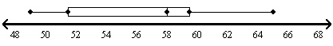
C.
minimum = 49, first quartile = 54, median = 58, third quartile = 59.5, maximum = 66
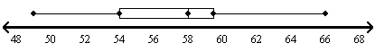
D.
minimum = 49, first quartile = 54, median = 59, third quartile = 64, maximum = 65
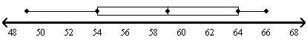

6)
For 52 math test scores, 50 are less than or equal to 95. What is the approximate percentile rank of the score 95?
A.
96
B.
4
C.
85
D.
15

7)
When you compare two sets of data, will the set with the greater range always have the greater interquartile range? Explain and give an example.
A.
Yes; the first box-and-whisker plot below has a larger range and interquartile range than the second.
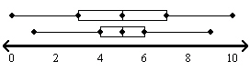
B.
Yes; the first box-and-whisker plot below has a larger range and interquartile range than the second.
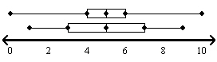
C.
No; the first box-and-whisker plot below has a larger range than the second, but a smaller interquartile range.
D.
No; the first box-and-whisker plot below has a larger range than the second, but a smaller interquartile range.

8)
Mr. Campbell promised that if most people in his class scored above 70% on a test, he would reward the class with a field trip. Which measure(s) of central tendency should you use to represent the test scores? Justify your answer.
A.
Mean; if the mean is above 70%, then the class average for the test is above 70%.
B.
Median; if the median is above 70%, then over half the class scored above 70%.
C.
Mode; if the mode is above 70%, then most people scored above 70%.
D.
All measures of central tendency are equally useful. If any of the mean, median or mode is over 70%, then most students in the class scored above 70%.

9)
Tell whether the histogram is uniform, symmetric, or skewed.
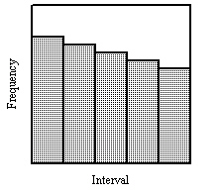
A.
uniform
B.
symmetric
C.
Skewed

10)
Tell whether the histogram is uniform, symmetric, or skewed.
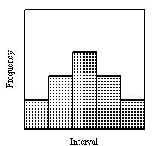
A.
uniform
B.
symmetric
C.
Skewed

11)
What are the mean, median, mode, and range of the set of data?
28, 31, 25, 22, 24, 32, 33, 25, 29, 23, 25
A.
27, 25, 25, 11
B.
27, 32, 25, 3
C.
32, 32, 25, 10
D.
none, 25, 25, 5

12)
Identify the minimum, first quartile, median, third quartile, and maximum of the data set. Then make a box-and-whisker plot of the data set.
race times: 50 35 30 45 30 44 46 47 65 31 39
A.
minimum = 30; first quartile = 31; median = 44; third quartile = 47; maximum = 65
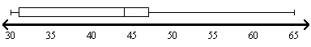
B.
minimum = 31; first quartile = 36; median = 45; third quartile = 48; maximum = 65
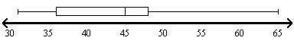
C.
minimum = 30; first quartile = 32; median = 39; third quartile = 60; maximum = 65
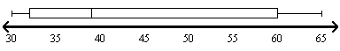
D.
minimum = 31; first quartile = 36; median = 45; third quartile = 48; maximum = 50

